Retrain Your Brain Away from Chronic Pain

## Compiled by Paul Hansma PhD, Researcher in the Neuroscience Research Institute, Faculty in the California NanoSystems Institute and Emeritus Professor in the Dept. of Physics, all at UCSB; a founder and the chief inventor at Active Life Scientific and former chronic pain sufferer.

It may seem hard to believe that intense chronic pain that has lasted for years can be eliminated or, at least, very much reduced, by retraining your brain. But, recent breakthroughs have made it possible for many people already, including a friend of mine and me. I want to share with you how it happened.

# **The first step is realizing that there is helpful pain and unhelpful pain**.

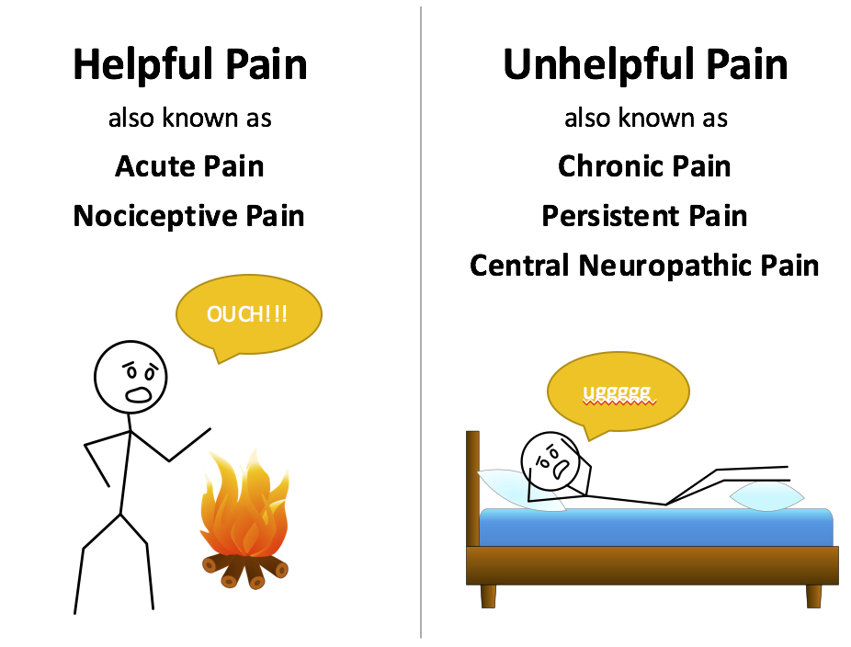

Helpful pain protects us. Unhelpful pain disables us. Experiencing intense pain of our lower back while lying in bed is not useful to us. Certainly not after the 3 months or so after which pretty much any repair that our body could do has been done. So why does this unhelpful pain exist?

Our unconscious brain decides whether or not to create the experience of pain based on whether it believes that it is helpful for us to experience pain. It gives a high priority to pain, over touch, skin temperature, beauty, music, fun etc. because helpful pain is very helpful! Without it, we would die young, from an accumulation of wounds, bruises, broken bones, and other health issues that went undetected. The problem is that the unconscious brain just doesn’t know when to quit! So how can we retrain the unconscious brain to make better decisions? With the conscious brain.

The conscious brain can do a better job on the very difficult task of deciding what pain is and is not helpful by reflecting on our experience, consulting physicians and the internet. One important guideline comes from the definition of chronic pain: pain that lasts more than 3 months. The body has pretty much done whatever healing it can do within 3 months. But during that time, sensitization can develop.

# The second step is learning about sensitization, which causes unhelpful pain.

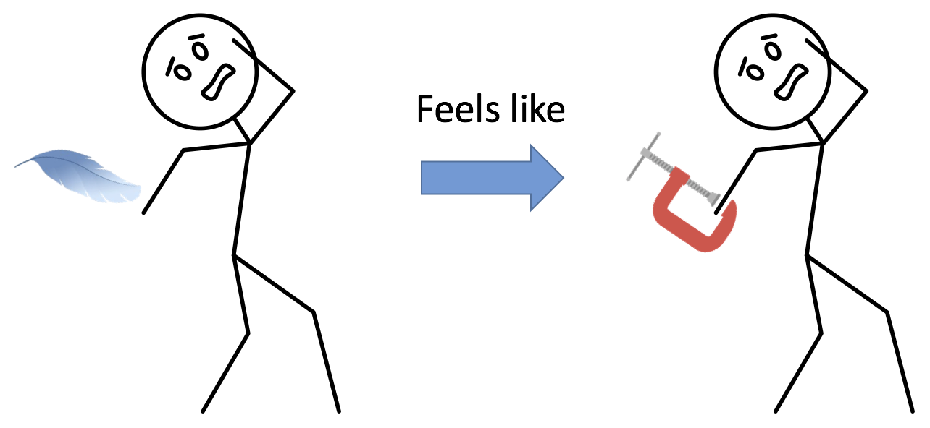

After a person has experienced pain for a long time they become so sensitized that even the touch of a feather can be painful (called allodynia). And something, such as a slightly sore muscle in the lower back, which would normally be experienced as just a little sore, can be intensely painful (called hyperalgesia). This causes chronic pain and a withdrawal from activity because even harmless motion can be intensely painful.

Once sensitization has occurred, we can no longer trust pain to be an accurate indicator of the condition of our body. Whatever body problems still exist after three months cannot be known because pain cannot be trusted! An extreme case is phantom limb pain in which the body part no longer even exists, but pain persists! Thus, whether or not there is a body problem, we can greatly benefit from working to reduce the brain problem of sensitization, so that pain can be trusted and helpful. We need to retrain our brains away from unhelpful, chronic pain, before we can even know whether there is a remaining body problem or not.

The most important goal is getting a clear understanding that you need to work on the brain portion of chronic pain to overcome chronic pain. **Once you shift your focus from body oriented therapies to brain oriented therapies, a whole new world of opportunities opens!!**

So first, let us focus on the root cause of sensitization, and thus chronic pain, by understanding the basic neuroscience of the brain problem. This understanding can help motivate us to retrain our brains away from chronic pain.

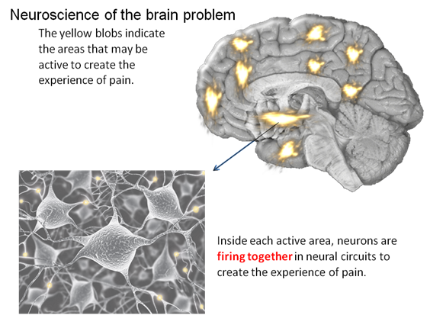

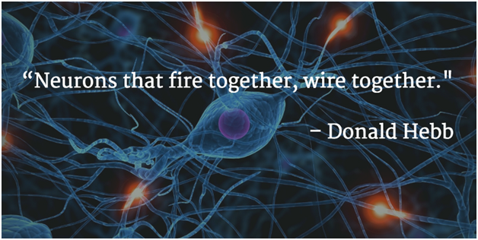

As neurons fire together they “wire together”, which means that it becomes easier and easier and for them to fire together in the same activity (for example, in creating the experience of pain).

So just as the brain gets better and better at helping us ride a bicycle with training, it gets better and better at “helping” us by creating the experience of pain with training. This is the training that we need to overcome by retraining our brain.

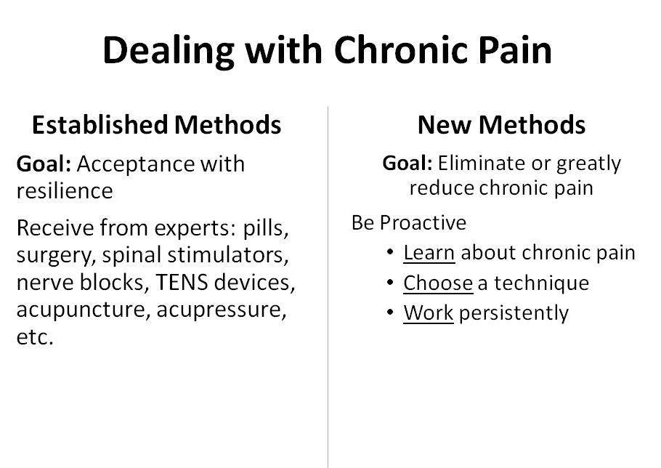

# The third step is choosing a method to retrain your brain away from unhelpful, chronic pain.

**Method 1: Visualization (Moskowitz)**

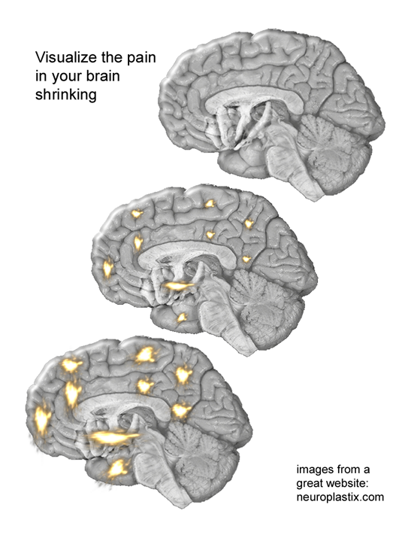

Imagine, with your mind’s eye, the yellow areas **SHRINKING**. Getting **SMALLER**. Repeat this whenever you feel pain. Focus on this mental imagery, not your body. Instead of reacting with “Why me?” or “Oh no, the pain is back” or “Will it ever go away” or other negative emotional thoughts, instead use the pain as a trigger to begin your visualization. The pain may not decrease at first, but you just keep at the visualization knowing that it takes time to take effect. Your brain learned to produce chronic pain over months. Though some people have some benefit right away, you can expect to spend weeks or even months to retrain your brain away from chronic pain. Keep heart with the knowledge that visualization has already minimized or eliminated the chronic pain of many others.

The New York Times bestselling book by Norman Doidge, The Brain’s Way of Healing, has two case histories of success.

1) Michael Moskowitz himself had a water-skiing accident that started 13 years of chronic pain, with average pain of 5/10 (self rating of 5 on a 0 to 10 scale) going as high as 8/10 on bad days and still 3/10 on good days. After he retrained his brain using visualization exercises based on the images now available on his web site, he started to get results within a month and in a year was almost always pain free, 0/10! Specifically, he visualized the areas of pain in the brain (yellow blobs in the images on the website and on the cover of the workbook above) shrinking.

2) A registered nurse heard the sound of a rubber band snapping and felt something inside of her break, as the full weight of a 280 pound patient damaged all five of her lower back discs. She became disabled, in chronic pain. *I was depressed and suicidal, and it didn’t matter what drugs the doctors gave me—the pain never went away. I couldn’t even watch TV or read because, on top of the pain, the drugs I took put me in a gray zone. There was no reason to live.*

Based on his own success, Moskowitz trained her to be relentless in visualizing the yellow blobs, representing the areas of pain in the brain, shrinking. By the fourth week she experienced pain-free periods of 15 to 30 minutes and thought, *This is going to go away.* She was right. After some more work the pain did go away and never came back. **Thus even in a case where there is real damage - surgeons told her that there was too much damage in her lower back to even operate - still retraining the brain away from pain works!**

It is interesting (and wonderful) that my friend’s success over her chronic pain came even quicker, within a few weeks! She wrote: *I'm finding this really incredible - and while I'm a bit reluctant to even say anything in case it jinxes the effects - and because it all seems so preposterous - I have to tell you that I looked at the Chronic Pain slides, the* [*neuroplastix.com*](http://neuroplastix.com/)*site, glanced at pieces of online videos and google references and now find myself quite suddenly pain free (or at least pain so diminished as to not be problematic). Wow! I still get small twinges and pain grabs but they are incredibly diminished. I seem to have a pain in my neck and arm, but just thinking about the pain maps in my brain - visualizing the slides, seems to be enormously helpful. This is really encouraging and quite crazy -- extraordinary really! I still feel a bit foolish - as if I have swallowed the Kool Aid and thrown away my crutches.  The truth about that? Who cares! I am walking and bending with relative ease ... Hallelujah.*

Some people, like me, cannot visualize. But if you can visualize and especially if you are good at visualization, this approach has the wonderful advantage that it is always available! If you start to experience pain while waiting in line at the supermarket or riding in a car or lying in your bed, you can just start visualization using only your mind. No other things are needed!

# **Method 2: Retraining by knowledge (Sarno)**

• Think psychological – for example, how do I feel emotionally right now?

• Educate yourself – read his books and watch his videos

• Resume normal activities

• Stop all physical treatments

• Affirmations- For example, every day I am feeling better.

• Form a support group.

• Psychotherapy (if necessary)

Dr. Sarno taught this method in a three hour lecture. He is now retired and recommends to just keep reading his books until your pain goes away. It worked for me! As I was reading his book, *The Divided Mind*, I was sitting in a recliner, with pillows under each arm to minimize my chronic shoulder pain. Suddenly I noticed pain in my right elbow. Now I knew that I had done nothing to damage the tissue in my right elbow that week. I found one part of my brain telling another part of my brain: *YOU'VE GOT TO BE KIDDING! CUT IT OUT!* And the pain in my elbow went away immediately.

It was the first time I knew for sure and at a very deep level that the source of my pain was my brain, and that my brain could be retrained away from pain. After that breakthrough, my complete recovery took about 6 months to gradually add back all normal activities. Qi Qong helped me add gentle movement and lose my fear of activity. It can also be helpful to use the affirmations “sore but safe” and “motion is lotion” that come from Graded Motor Imagery as well as its other techniques.

# **Method 3: Graded Motor Imagery (Moseley)**

• Imagine the motion you would like to do.

• For example, imagine getting up out of bed and walking to the kitchen. Repeat this until you are ready to actually do it.

• Watching others move can also be helpful (mirror neurons).

• Using a mirror box.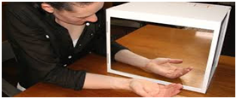

# **4. Biofeedback at home (warming hands)**

• Use a thermometer to monitor your hand temperature as you practice. A digital one for just this purpose is available on Amazon for about $20.

• Try phrases like: My arms and legs are heavy and warm. My breathing is calm and regular. My heartbeat is calm and regular. My muscles are relaxed. I can feel the blood running into my hands. Repeat slowly for about 10 minutes.

• You can also try other relaxation techniques like deep breathing or imagery (for example, imagine lying on a warm beach) or any technique that has helped you relax in the past.

• Initial training should be done when you are comfortable – not during an intense pain episode. It may take 5 to 10 training sessions to get all the way to a temperature of 90 – 95 degrees. Daily practice acts as a preventative therapy.

63% of migraine headache sufferers were helped by learning to warm their hands on a daily basis as a preventative therapy. Its effectiveness for other forms of chronic pain has not yet been studied well enough. There is, however, evidence for its effectiveness in helping reduce stress and anxiety, which can contribute to all forms of chronic pain.

# **Final remarks**

These are four established methods to retrain your brain away from pain that have worked for many people already. There are other techniques, such as meditation and hypnosis that can also be effective. If you want more information, there are links that you can click to get you to the current version of longer document on the hansmalab website: http://hansmalab.physics.ucsb.edu/. It has much more detail about the science of pain with references to scientific articles, websites, books, Youtube videos, and other general information. There are also links to the most current version of this document and to a document with resources for retraining your brain.

Of particular importance, once you have a breakthrough and really experience that your brain can be retrained away from pain, are methods to restore normal activity (and fun!) to your life. For me, the gentle exercises of Qigong were helpful for me. Tai Chi would probably also have similar benefits. Or use the techniques of Graded Motor Imagery (see above) after you have a breakthrough with one of the other techniques.

# **Resources for retraining by visualization:**

[Neuroplastix.com](http://neuroplastix.com/) This amazing and wonderful website is the source of the images for visualization. This website also has lots of background information and products including the *Neuroplastic Transformation Workbook* that can lead you through a wonderful structured program with visualization at its heart.

Doidge, Norman. *The Brain's Way of Healing: remarkable discoveries and recoveries from the frontiers of neuroplasticity*. Penguin Books, 2016. This book has the two detailed success stories for retraining your brain by visualization as well as great background material.

# **Resources for retraining with knowledge:**

YouTube videos

John E Sarno M.D. - 20/20 Segment. This short video and his books helped me overcome my chronic pain by convincing me that the source of my pain had become my brain.

John E. Sarno M.D. On The Howard Stern Show. Documents how retraining your brain can dramatically improve your quality of life.

Daniel J. Clauw M.D. Chronic Pain – Is it All in Their Head? Wonderful material about the downward spiral of pain/(inactivity, lack of sleep, stress) and its reversal starting 1:14 after a great discussion about the differences between chronic “brain pain” and acute (nociceptive) pain.

Silje Endersen Reme Pain, Is it all in your mind? This TED talk supports Dr. Sarno’s idea that underlying psychological issues can be a major factor in back pain.

Elliot Krane M.D. The mystery of chronic pain. This video has a wonderfully informative story about sensitization and its reversal in a young woman.

### **Books and Websites**

Sarno, John E. *Healing back pain: The mind-body connection.* Grand Central Publishing, 2001.

*S*arno, John E. *The mindbody prescription: Healing the body, healing the pain*. Grand Central Publishing, 2001.

Sarno, John E. *The divided mind*. Harper Collins, 2009.

A great website for Dr. Sarno’s approach that includes a link to medical evidence: [tmswiki.org/ppd/An_Introduction_to_Tension_Myositis_Syndrome_(TMS)](http://www.tmswiki.org/ppd/An_Introduction_to_Tension_Myositis_Syndrome_(TMS))

All Care Visiting Nurse Association and Hospice has a wonderful web document on the modern theory of pain.  [allcare.org/CancerPain-and-SymptomManagement/comfort/cfm2/cfm2_cont.htm#5e](http://www.allcare.org/CancerPain-and-SymptomManagement/comfort/cfm2/cfm2_cont.htm#5e)

# **Resources for Retraining with Graded Motor Imagery:**

There is lots of information about Graded Motor Imagery at  [gradedmotorimagery.com/](http://www.gradedmotorimagery.com/) and evidence-based multimedia resources and courses for the treatment of pain at [**noi**group.com/](http://www.noigroup.com/).

Lorimer Moseley M.D. Body in mind - the role of the brain in chronic pain. This **YouTube video has** a great story about how meaning affects the experience of pain starting at 2:00, but I recommend watching the whole thing for some of the first research studies that are relevant to retraining the brain.

# **Resources for Retraining with Biofeedback at home:**

<http://bio-medical.com/resources/temperature-biofeedback-hand-warming-explanation/>

Sargent, Joseph D., Elmer E. Green, and Dale E. Walters. "Preliminary report on the use of autogenic feedback training in the treatment of migraine and tension headaches." *Psychosomatic Medicine* 35.2 (1973): 129-135.

# **Professional Help:**

Though there are lots of professionals in the Santa Barbara that can prescribe pills and perform physical procedures such as implanting stimulators and infusion devices, the only two professionals that I have been able to find, so far, that can help with retraining the brain are:

1) Ken Pfeiffer, PhD. ken@painrelievers.org He is author of the wonderful website on chronic pain, [www.painrelievers.org](http://www.painrelievers.org/).

2) Susan Farber, MFT, 22 W. Micheltorena St. Suite B (805) 886-5538 and 240 East Highway 246 Suite 210 Buellton, CA 93427

<http://www.susanfarbermft.com/>

If you find someone else, please let me know so I can add them to this evolving document.

# **Final remarks**

Good luck! Please share your experiences and any useful resources that would help improve this document for others. You can email me at phansma@ucsb.edu